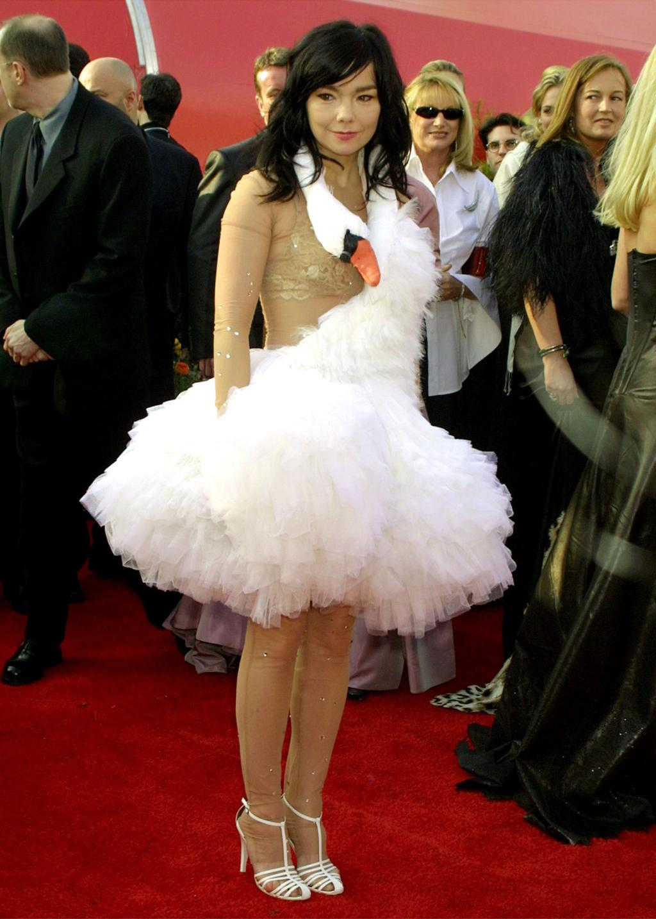The Swan Dress: an object history
Marjan Pejoski’s swan dress is best understood not as a one-night spectacle but as an object with several lives. It first appeared on Pejoski’s Fall 2001 runway in London, where Vogue described the closing look as transforming Alek Wek into a swan. The Design Museum later noted that this was where Björk first encountered the piece before carrying it out of fashion-week context and into mass culture. In construction and silhouette, the garment behaved less like conventional eveningwear than like wearable sculpture: a nude-toned bodysuit, a cloud of white tulle, and a swan’s long neck curving around the torso so that the dress seemed both to perch on the body and to animate it. (Vogue)
Its second life began at the 73rd Academy Awards in 2001, where Björk wore it while nominated for Best Original Song for “I’ve Seen It All” from Dancer in the Dark. On the Oscars red carpet, the dress changed category: it stopped being only a runway look and became a performance. Björk also amplified the image with egg imagery, turning the outfit into something closer to live visual art than celebrity dressing. Later explanations linked the look to the stylized glamour of Busby Berkeley and Esther Williams, as well as to the wintery visual world of Vespertine, which makes the dress feel less random than it first seemed and more like a deliberate piece of image-making. (Oscars)
Its third life was as iconography. Björk wore the dress again for the cover of Vespertine, extending it from red-carpet event into album image. Its fourth life was as museum object. The Metropolitan Museum of Art included the dress in Camp: Notes on Fashion, where the exhibition defined camp through irony, humor, theatricality, and exaggeration; the Met’s selected images identify the piece as Pejoski’s swan dress from fall/winter 2000–2001. The Design Museum later presented it in REBEL: 30 Years of London Fashion, emphasizing that what once generated shock and headlines had since become one of the most recognizable red-carpet looks in fashion history. (The Metropolitan Museum of Art)
Seen this way, the swan dress is not merely an infamous Oscar outfit. It is an object biography: runway experiment, red-carpet provocation, album symbol, museum artifact. Its importance lies in how fully it rejected the usual job of formalwear. Instead of flattering, smoothing, or disappearing into glamour, it insisted on narrative, theatricality, and risk. What was mocked at the time now reads as a design object that anticipated the modern red carpet, where fashion is expected not just to decorate a body but to carry an idea. That is why the dress endures: not because it was strange, but because it changed what a famous dress could do.
I can also turn this into a more academic museum-label voice or a more lyrical magazine voice.

